IW Express API Documentation

Table of Contents
API #1: Softdata Upload 3
API #2: Shipping Label 5
API #3: Consignment Tracking 6
Client Status Update Webhook 7

API #1: Softdata Upload

API URL: http://15.207.62.25:5001/iwexpress/softdata/upload
Request Type: POST
Input Authorization as like below.
Basic $2a$10$qWHNeBhu4FCGoJfuv2XVbO9Yq4QBUwGSvNM0bGpYUVc3iY8jXsJwO
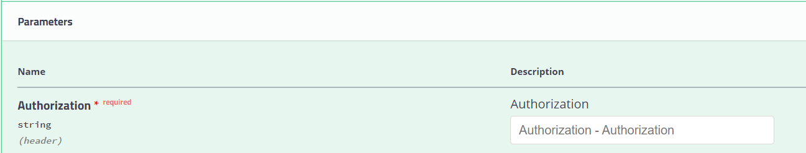

Order Details as like below structure (JSON Provided)
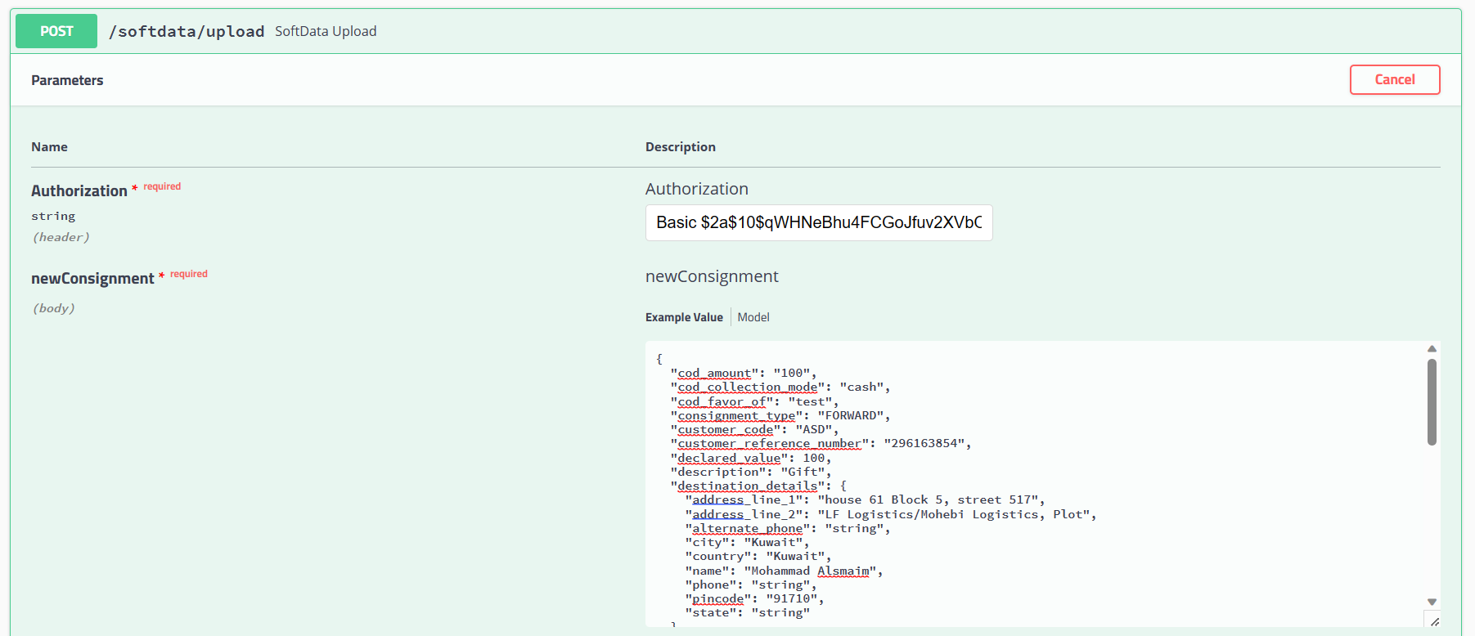
Request JSON
{
"cod_amount": "string",
"cod_collection_mode": "string",
"cod_favor_of": "string",
"consignment_type": "string",
"customer_code": "ASD",
"customer_reference_number": " 296163854",
"declared_value": 0,
"description": "string",
"destination_details": {
"address_line_1": "string",
"address_line_2": "string",
"alternate_phone": "string",
"city": "string",
"country": "string",
"name": "string",
"phone": "string",
"pincode": "string",
"state": "string"
},
"dimension_unit": "string",
"height": "string",
"is_risk_surcharge_applicable": true,
"length": "string",
"load_type": "string",
"notes": "string",
"num_pieces": 0,
"origin_details": {
"address_line_1": "string",
"address_line_2": "string",
"alternate_phone": "string",
"city": "string",
"country": "string",
"name": "string",
"phone": "string",
"pincode": "string",
"state": "string"
},
"pieces_detail": [
{
"declared_value": 0,
"description": "string",
"height": 0,
"length": 0,
"weight": 0,
"width": 0
}
],
"service_type_id": "string",
"weight": 0,
"weight_unit": "string",
"width": "string"
}

SAMPLE REQUEST
{
"cod_amount": "100",
"cod_collection_mode": "cash",
"cod_favor_of": "test",
"consignment_type": "FORWARD",
"customer_code": "ASD",
"customer_reference_number": "296163854",
"declared_value": 100,
"description": "Gift",
"destination_details": {
"address_line_1": "house 61 Block 5, street 517",
"address_line_2": "LF Logistics/Mohebi Logistics, Plot",
"alternate_phone": "string",
"city": "Kuwait",
"country": "Kuwait",
"name": "Mohammad Alsmaim",
"phone": "string",
"pincode": "91710",
"state": "string"
},
"dimension_unit": "CM",
"height": "5",
"is_risk_surcharge_applicable": true,
"length": "10",
"load_type": "DOCUMENT",
"notes": "test",
"num_pieces": 10,
"origin_details": {
"address_line_1": "LF Logistics/Mohebi Logistics, Plot",
"address_line_2": "Mohebi Logistics; Plot WT01 & WT04",
"alternate_phone": "",
"city": "Dubai",
"country": "UAE",
"name": "The Hut Group",
"phone": "97101606811863",
"pincode": "8005",
"state": "DUBAI"
},
"pieces_detail": [
{
"declared_value": 100,
"description": "Gift",
"height": 100,
"length": 500,
"weight": 1.2,
"width": 200
}
],
"service_type_id": "PREMIUM",
"weight": 1.2,
"weight_unit": "KG",
"width": "200"
}

API #2: Shipping Label

API URL : http://15.207.62.25:5001/iwexpress/{referenceNumber}/shippingLabel
Request Type : GET
Authorization:
Basic $2a$10$qWHNeBhu4FCGoJfuv2XVbO9Yq4QBUwGSvNM0bGpYUVc3iY8jXsJwO
referenceNumber:
[consignment reference number]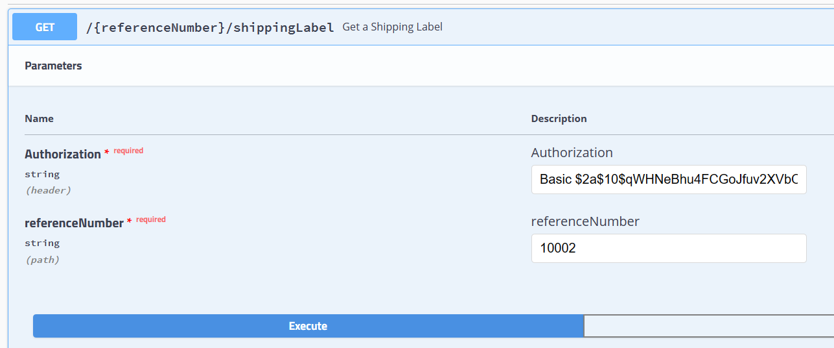

Sample Request:
http://15.207.62.25:5001/iwexpress/10002/shippingLabel

Response JSON: [PDF Stream response]

API #3: Consignment Tracking

API URL : http://15.207.62.25:5001/iwexpress/tracking/{referenceNumber}/shipment
Request Type : GET
Authorization:
Basic $2a$10$qWHNeBhu4FCGoJfuv2XVbO9Yq4QBUwGSvNM0bGpYUVc3iY8jXsJwO
referenceNumber:
[consignment reference number]
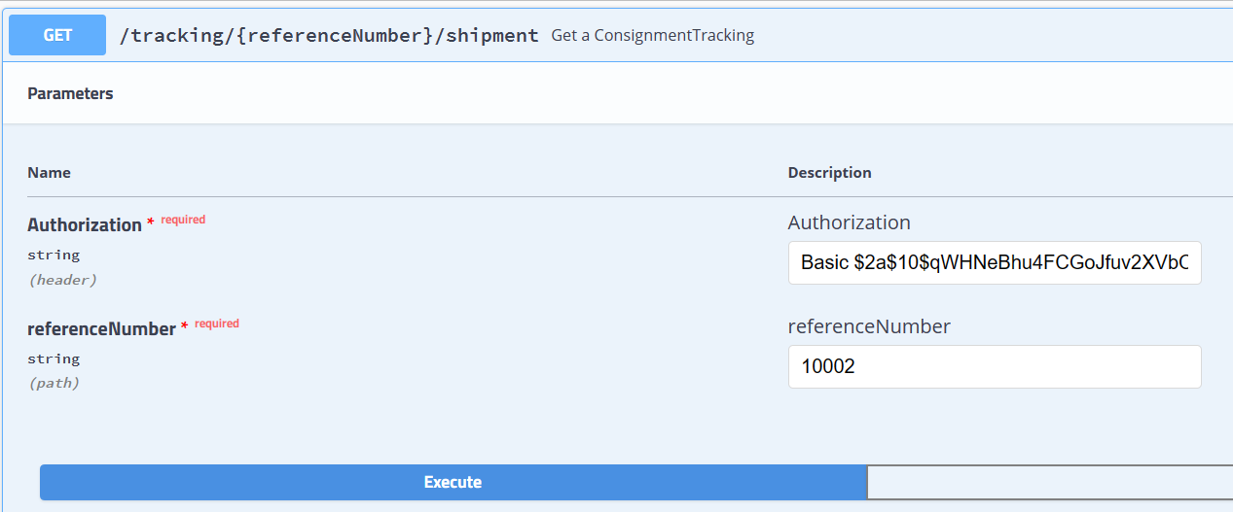

Sample Request:
http://15.207.62.25:5001/iwexpress/tracking/10002/shipment
Response JSON: [Consignment Tracking details]

Client Status Update Webhook

Following are the list of events (with description) supported which is provided in the key type as seen in the payload.
- accept - When the consignment is out for delivery
- added_to_bag - When the consignment is added to a bag in a trip
- assigned_for_delivery - When an consignment is assigned to any rider for delivery
- assigned_to_hub - When task is assigned to rider for delivery
- attempted - When a consignment is undelivered
- bag_received - When bag is unloaded from the trip
- cancelled - When a consignment is cancelled
- consignment_verification - When consignment Verification is done
- customs_clearance_completed - When the consignment is cleared from customs
- delay_at_airport - When the consignment is at airport and not processed due to some reasons
- delivered - When a consignment is delivered
- delivery_pod - When the 3PL send s POD separately post the delivered event (Select this event is you ar using delivered event)
- deps_exception - When the consignment is received as Damaged, Excess, Shortage or Pilferage
- exception - When a event is received that does not belong to other events in the list
- handed_in_customs_clearance - When the consignment is handed to the customs at airport
- handover_courier_partner - When the consignment is handed over to the 3PL
- inscan_at_hub - When a consignment is inscanned at any hub
- intransittohub - When a consignment is part of any mid mile hub and the mid mile trip is ongoing
- lost - When a consignment is lost
- not_picked_up - When the consignment is not picked up
- on_hold - When consignment is put on hold for some reasons
- out_for_pickup - When the delivery executive is out for pickup
- out_for_store_pickup - When the delivery executive is out for pickup (PUDO Flow only)
- outscan_at_hub - When a consignment is marked as outscan from a hub
- pickup_awaited - When the delivery executive is yet to be assigned for pickup
- pickup_completed - When the pickup is completed by the delivery executive
- pickup_scheduled - When the pickup has been scheduled for a consignment
- reachedathub - When the consignment reached the destination hub (generally the last mile hub)
- release_on_hold - When a consignment is released from hold
- reschedule - When the consignment pickup or delivery is rescheduled
- returned_at_hub - When the consignment is received at hub post a delivery attempt
- revert_from_delivered - When a consignment is revoked from delivery for exceptional reasons (Aplicable from CRM)
- revoke_rto - When RTO is revoked for exceptional reasons (Applicable from CRM)
- rto - When the consignment is marked as RTO
- rto_attempted - When the consignment is undelivered in a RTO journey
- rto_delivered - When the consignment is delivered in a RTO journey
- rto_in_transit - When the consignment is in transit in a RTO journey
- rto_initiated - When the consignment is marked as RTO (this is a preferred over the event rto)
- rto_inscan_at_hub - When the consignment is inscanned at hub in a RTO journey
- rto_outfordelivery - When the consignment is out for delivery in a RTO Journey
- seized - When the consignment is seized by an external party before being delivered
- shelved - When the consignment is shelved for some reasons
- softdata_upload - When consignment is created in Shipsy system
- vehicle_arrived - When the vehicle has arrived to a different hub in a middle mile trip

